BRITISH COLUMBIA LIBRARY ASSOCIATION
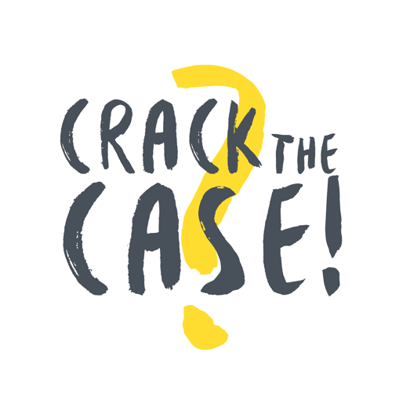

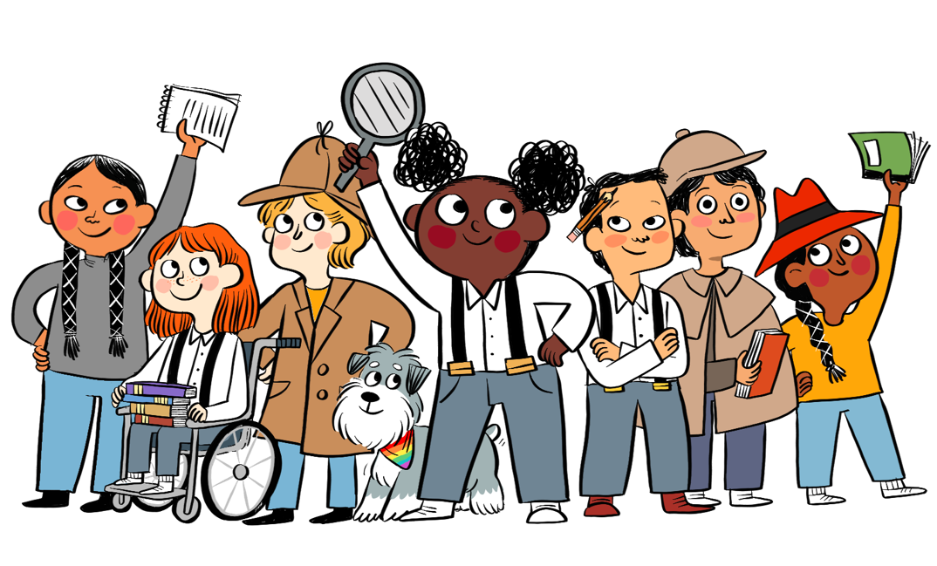

Certificate of Completion

Congratulations!

has completed the 2021 Crack the Case! Summer Reading Club

Library Date

