BC Summer Reading Club 2022 Press & Media Information

About BC Summer Reading Club
BC Summer Reading Club is a free literacy program encourages reading throughout the summer and engages children (ages 5-14 years old) with their public library. Summer Reading Club is a fun, educational, inclusive and community-oriented program that began over 30 years ago.
BC Summer Reading Club is sponsored by the British Columbia Library Association and BC public libraries with the generous assistance of Public Libraries Branch, Ministry of Municipal Affairs, and CUPE BC.
For more information about BC Summer Reading Club, there are two resources available in a variety of languages for libraries, settlement organizations, and community partners:
- Value of Summer Reading Club leaflet
- “What is BC Summer Reading Club?” brochure

BC SRC 2022 Details
Every summer, our libraries vote on a theme suggested by library across the province. This year’s theme is All Together Now – a celebration of communities and connection. We were fortunate to work with Vancouver-based illustrator and artist, Elaine Chen, as this year’s BC SRC artist.
Seven weekly sub-themes carry the club through the summer:
- Community Connections - My neighbourhood, friends, school, and community helpers
- Hello World - Travel and moving, world languages, international celebrations
- Dream Team - Sports, organized group activities and games
- Great Outdoors - Exploring our connection to the environment, the natural world
- Together, Apart - Internet and phone technology, long-distance communication (letters, postcards)
- All Kinds of Families - Families (including found families) and family celebrations
- Let’s Play Together - Working together, cooperation, and teamwork

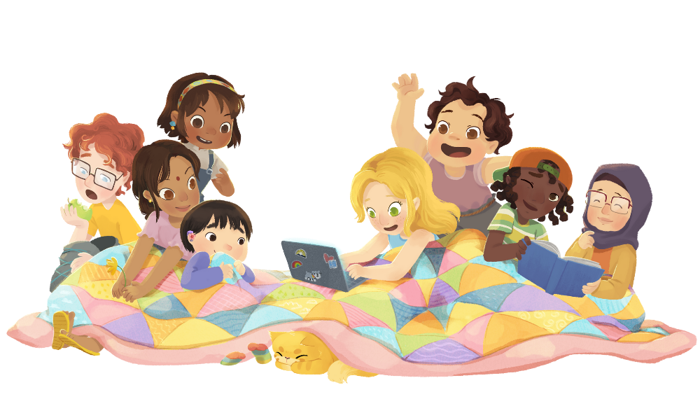
How to Participate

BC SRC welcomes all children and their families to participate. We encourage children to visit their local public library to register and pick up a reading record, new books to read, and learn about events and programs happening in their community. Furthermore, BC SRC also has an online participation option including an online reading tracker, activities, contests, events, and more that can be found on bcsrc.ca.

Throughout the summer, participants track their daily reading goals (this could be set by the library or their own choice). All types of reading are encouraged including reading in other languages, listening to audiobooks and oral stories, and more. For accessible reading options, please check in with your library to see what is available.

Online registration opens on June 13th and local libraries will open registration in mid-to-late June.

