2022 BC Summer Reading Club

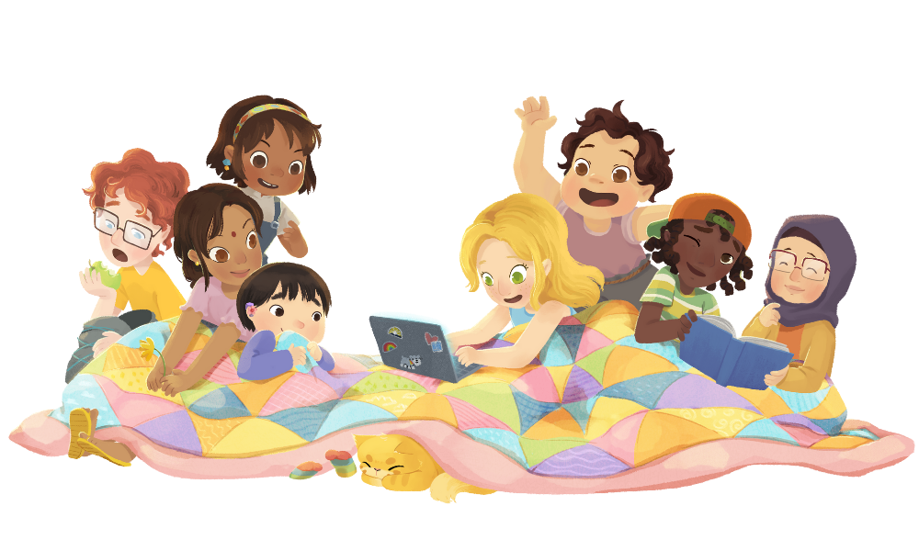

BC Summer Reading Club is FREE and FUN at your local library
A great way to maintain or improve reading skills over the summer!
2022 BC Summer Reading Club

BC Summer Reading Club is FREE and FUN at your local library
A great way to maintain or improve reading skills over the summer!

Use this space to promote your library’s SRC programs, activities and provide contact info
Use this space to promote your library’s SRC programs, activities and provide contact info

We look forward to
seeing you and your family this summer!
www.bcsrc.ca
We look forward to
seeing you and your family this summer!
www.bcsrc.ca

